***Lyddie***

***Chapter 14 – Speed Up***

Lyddie lay in bed for a few days as the wound on her head [healed](http://bookbuilder.cast.org/view_glossary.php?book=111146&word=86236#curr) .  By Sunday, Lyddie was saying that she was well enough to go back to work on Monday.  Mrs. Bedlow and Betsy tried to tell her that she should wait, but Lyddie promised them and Mr. Marsden that she was well enough to go back to work.  And besides, she could not afford to lose out on any more money because of her head.



That night, as Lyddie lay in bed she heard Betsy start to cough. She had heard this cough before.  It was loud and [constant](http://bookbuilder.cast.org/view_glossary.php?book=111146&word=86237#curr)  and Lyddie knew it was very painful.

Amelia told Betsy, "I wish you would see a doctor about that cough"

Betsy said, "I'm a big girl Amelia, don't bother me about it.  All a doctor will do is tell me to stop and rest, but I can't stop.."

Amelia said, "I'm going to stop.  I'm leaving, going home.  I can't keep up this pace anymore and I've really come to hate factory life"

Betsy tried to convince her to stay at least through the summer and for a while Amelia agreed as long as Betsy promised to go and see a doctor about her cough.

However, during the last week in January Amelia left to visit home and did not [return](http://bookbuilder.cast.org/view_glossary.php?book=111146&word=86238#curr) .



The next day in the factory Mr. Marsden came up to Lyddie.  He told her that she was his best girl and wanted to make sure she was taking care of her head.

Also, he told her that some new girls were coming to start work in the factory and he asked Lyddie if she would teach one, like Diana had taught her.  Lyddie did not want to because she was worried a new girl might slow her down and cause her to make less money.  However, Mr. Marsden did not really leave her a choice, but did promise it would only be for a day or so.



The next day Lyddie met the new girl.  Her name was Brigid and she was Irish.  Lyddie tried to go slowly and to teach her, but it was hard.  Lyddie wasted five [precious](http://bookbuilder.cast.org/view_glossary.php?book=111146&word=86239#curr)  minutes just teaching her how to tie one knot!

Lyddie remembered how [overwhelming](http://bookbuilder.cast.org/view_glossary.php?book=111146&word=86240#curr) it was on her first day in the factory, but she was still [impatient](http://bookbuilder.cast.org/view_glossary.php?book=111146&word=86241#curr) with the new girl.

Lyddie told Brigid that it would get better as she got more practice.  By the end of the first day, Lyddie knew that Brigid was not ready for her own machine but Lyddie had lost her patience.  She instead asked Mr. Marsden to give her the machine next to her own and Lyddie would watch out for her that way.



Lyddie found out that Betsy had signed the petition.  Lyddie was very upset and worried that Betsy would get fired and [backlisted](http://bookbuilder.cast.org/view_glossary.php?book=111146&word=86242#curr)  and that Betsy would have no where to work.

However, it never came to that because soon, Betsy's cough had gotten so bad that she had to ask for a [transfer](http://bookbuilder.cast.org/view_glossary.php?book=111146&word=86243#curr) to a different room where the air would be cleaner.

Then, Betsy's cough got so bad that she was coughing up blood and had to be sent to the hospital.



Lyddie would go and visit Betsy in the hospital and would bring her the [botany](http://bookbuilder.cast.org/view_glossary.php?book=111146&word=86244#curr)  books she had been studying.  Betsy wanted to get out of the hospital as soon as possible because it was so expensive.

Soon, Betsy's uncle came to pick her up and take her to [Maine](http://bookbuilder.cast.org/view_glossary.php?book=111146&word=86245#curr)  where he lived.  But, by then Betsy had spent almost all of her [savings](http://bookbuilder.cast.org/view_glossary.php?book=111146&word=86246#curr) on her care at the hospital.  Betsy promised she would be back the next year to start all over again, but she never came back.



One day when Lyddie was coming in for her noon meal she was met with a big surprise. There, standing in the door was Luke Stevens! Lyddie almost hadn't recognized him because he was wearing different clothes.

Luke came up to Lyddie and said hello and told her that his father had given him a package to bring to her.  Lyddie took the package and thanked Luke.  She offered him some food, but he said no and that he had to hurry to Boston on business.

Luke told Lyddie that he had seen Charlie and that he was still doing well at the mill. Then, just as quickly as he came, Luke left.

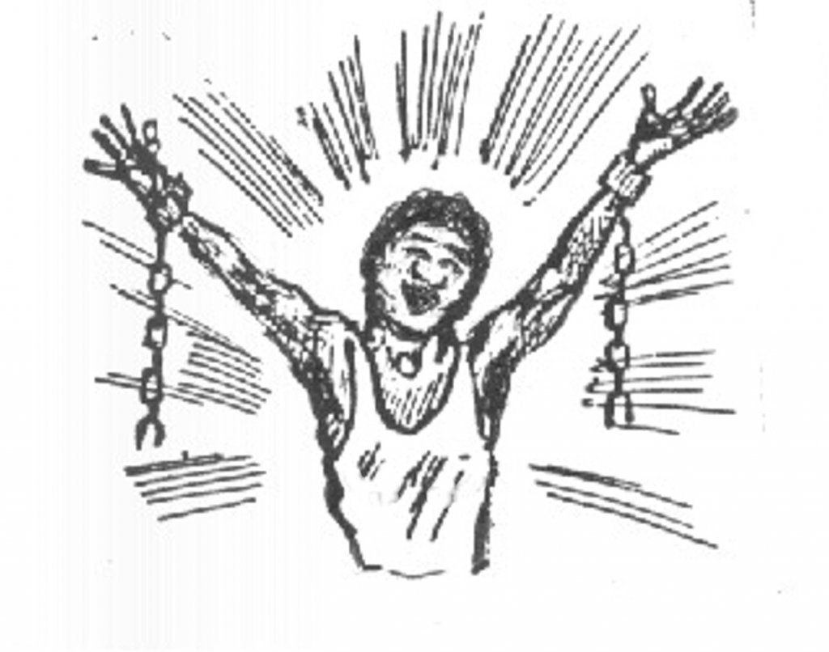

Then, Lyddie opened the letter that had come with the package.  It said,

My Dear Miss Lydia,

By now you have [despaired](http://bookbuilder.cast.org/view_glossary.php?book=111146&word=86247#curr)  of me and decided that I am a man who does not [honor his word](http://bookbuilder.cast.org/view_glossary.php?book=111146&word=86248#curr) .  Please forgive how late I am in sending this.  Thanks to the friendship of you and the Stevens' I was able to make my way safely to Canada.  I have now the great joy of being able to see my family.  In this package you will find the money that I borrowed from you, plus what else I could put together to thank you for all of your kindness.

With [everlasting gratitude](http://bookbuilder.cast.org/view_glossary.php?book=111146&word=86249#curr) , your friend,

Ezekiam Freeman



Lyddie finished reading the letter and then couldn't believe her eyes because in front of her sat fifty dollars !! Lyddie wanted to run right away to the bank and deposit the money.  Lyddie was so excited and knew that she must be close to being able to pay back the debt.

Then, Lyddie wondered why she hadn't heard from her mother. Lyddie wrote her another letter saying that she needed to know the total amount of the debt.  Lyddie hoped that her mother knew how much it was so she could pay it off completely. Lyddie slipped a dollar into the letter and mailed it off.

That night, Lyddie could barely sleep she was so excited.

A petition is going around the mill. The girls working there are being asked to sign it, if they want to show their support for a shorter work day.  If a girl signs it, she does so knowing that she may be fired and blacklisted from other jobs. Betsy is one of the girls that signs the petition, but she is dismissed because of her cough, which is likely tuberculosis.

[Lyddie](https://www.enotes.com/topics/lyddie?en_action=hh_answer_body_click&en_label=%2Fhomework-help%2Fsummary-lyddie-480748%23answer-686063&en_category=internal_campaign) has become the factory's best worker and consequently has been assigned the task of training a new worker.  Lyddie is not happy about her assignment and is not a patient teacher. She would rather be working her own looms. She feels that her student is exceptionally dense and therefore all Irish immigrants must be equally stupid. By the end of the day, Lyddie no longer has the patience to teach her pupil any longer, so she tells the boss to assign the girl to her own loom. Lyddie knows the girl is not ready and is being put into a potentially dangerous situation, but she doesn't care. That act shows how cold and selfish Lyddie has become by this point in the story.

In Chapter 14, [Lyddie](https://www.enotes.com/topics/lyddie?en_action=hh_answer_body_click&en_label=%2Fhomework-help%2Fwhat-summary-for-chapters-14-and-15-lyddie-24229%23answer-33295&en_category=internal_campaign) returns to work before she is fully recovered from being hit by the shuttle.  The working conditions at the factory are taking a toll on everyone - Amelia returns home, and Betsy, who has had a terrible cough, gets very sick and must be put in the hopital.  At work, to her chagrin, Lyddie is given a new girl to train, an "Irish papist" named Brigid.  The girl is inept, and Lyddie finds it hard to be patient with her because her own piecework is compromised.  Luke Stevens pays a surprise visit, and delivers a draft from Ezekial Freeman for fifty dollars.  Lyddie, hoping it is enough to pay the debt on the farm, writes to her mother to ask the total sum due.